Mahakal Institute of Technology, Ujjain



A Major Project Phase-I Report Submitted to
Rajiv Gandhi Proudyogiki Vishwavidhyalaya, Bhopal
Towards Partial Fulfillment for the Award of
Bachelor of Engineering (Information Technology)
2018-2019

Project Title

Airline Management System

Guided by: Submitted by:
Prof. Neha Agrawal Sanket Gupta
Smita Vishwakarma
Chintan Atre

Department of CSE & IT
Mahakal Institute of Technology, Ujjain
Rajiv Gandhi Proudyogiki Vishwavidhyalaya, Bhopal
(www.mitujjain.ac.in)
Certificate

This is to certify that Mr. Sanket Gupta, Ms. Smita Vishwakarma, Mr. Chintan Atre students of B.E. IV Year, VII semester of Information Technology Department, University Institute of Technology, Rajiv Gandhi Proudyogiki Vishwavidyalaya, Bhopal(M.P.) have completed their Major Project entitled Airline Management System.

They have submitted their Project Report for the partial fulfillment of the curriculum of the Degree of Bachelor of Engineering in Information Technology from Mahakal Institute of Technology, Rajiv Gandhi Proudyogiki Vishwavidyalaya, Bhopal.

Prof. Rajlakshmi Garg Prof. Abhishek Raghuvanshi
Project Coordinator Head of Department

Recommendation

The project entitled “Airline Management System” submitted by Sanket Gupta, Smita Vishwakarma and Chintan Atre is a satisfactory account of the bonafide work done under our guidance is recommended towards partial fulfillment for the award of the Bachelor of Engineering (Information Technology) degree from Mahakal Institute of Technology, Ujjain affiliated by Rajiv Gandhi Proudyogiki Vishwavidhyalaya, Bhopal.

Date:

Project Guide Project Coordinator
Prof. Neha Agarwal Prof. Rajlakshmi Garg
Mahakal Institute of Technology,
Ujjain

Endorsed By

Head

Department of CSE & IT
Mahakal Institute of Technology,
Ujjain

Acknowledgement

We are grateful to Prof. Rajlakshmi Garg for her even willingness to give us valuable advice and direction, whenever we approached her with a problem. We are thankful to her for providing immense guidance for this project.

We are also thankful to Prof. Neha Agrawal Department of Information Technology MIT- RGPV.

Sanket Gupta 0704IT151029
Smita Vishwakarma 0704IT151035
Chintan Atre 0704IT151009

Abstract

This is a project on Airline Management System is used at different reservation agency to reserve to seats for passengers online. It is a customer oriented software and easy to use. The Information System is an attempt to integrate the services offered by the different airlines and companies across the world. It proposes to make the process of flight reservation, Internet based, where the different airlines will have a common single platform for reservation of seats into their flights. Thus, it aims at benefiting the travelers as well as the airlines concerned. The objective in making this project is to better facilitate reservation system to make it more customers convenient. In addition, cover every aspect in satisfying the needs and the requirements that should be fulfilled by the reservation agency, for the satisfaction of its customers.

Table of Contents Page no.

List of Tables…………………………………………………………………
Abstract………………………………………………………………………
- Introduction………………………………………………………………….. 1
  - Problem Description………………………………………………... 2
  - Project Description…………………………………………………. 3
  - Proposed System with Objective…………………………………... 3
- Feasibility Study…………………………………………………………… 6
  - Existing System and Limitations…………………………………… 7
  - Feasibility Study…………………………………………………….. 7
    - Economic Feasibility Study…………………………………….
    - Technical Feasibility Study
    - Behavioral Feasibility Study

3. System Analysis…………………………………………………………… 8
3.1 System Analysis……………………………………………………….. 9
3.2 Preliminary Investigation…………………………………………….. 9
3.3 Requirement Specification…………………………………………… 10
3.3.1 Hardware Specification…………………………………………
3.3.2 Software Specification…………………………………………..

4. System Design……..……………………………………………………….. 11
4.1 Use Case Diagram……………………………………………………. 12
4.2 Use Case Description…………………………………………………. 12
4.3 Data Flow Diagram…………………………………………………… 13
4.4 Activity Diagram……………………………………………………... 16
4.5 Sequence Diagram……………………………………………………. 17

5. System Testing……………………………………………………………… 18

6. Conclusion………………………………………………………………….. 21

7. Bibliography and References……………………………………………… 24

LIST OF TABLES

Table 1: Showing Administrator’s Details.
Table 2: Showing Package Detail.
Table 3: Showing customers Detail.

LIST OF FIGURES

Abstract

This is a project on Airline Management System is used at different reservation agency to reserve to seats for passengers online. It is a customer oriented software and easy to use. The Information System is an attempt to integrate the services offered by the different airlines and companies across the world. It proposes to make the process of flight reservation, Internet based, where the different airlines will have a common single platform for reservation of seats into their flights. Thus, it aims at benefiting the travellers as well as the airlines concerned. The objective in making this project is to better facilitate reservation system to make it more customers convenient. In addition, cover every aspect in satisfying the needs and the requirements that should be fulfilled by the reservation agency, for the satisfaction of its customers.

Chapter 1
introduction
1.1 Problem Description
The definition of our problem lies in manual system and a fully automated system.

Manual system: The system is very time consuming and lazy. This system is more prone to
errors and sometimes the approach to various problems are unstructured.

Technical system: With the advent of latest technology if we do not update our system then
our business results in losses gradually with time. The technical systems contains the tools of latest trend i.e. computers printers, fax, Internet etc. The systems with this technology are very fast, accurate, user-friendly and reliable.
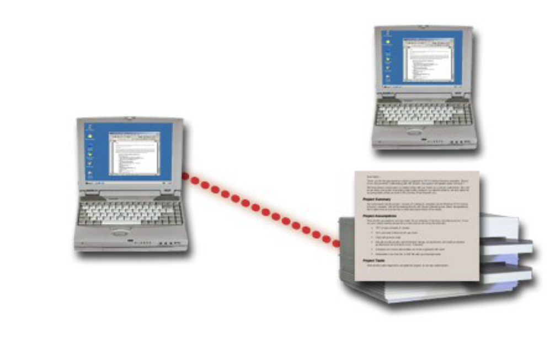
.

Fig.1

Need of Airlines system
A few factors that direct us to develop a new system are given below -:
1) Faster System
2) Accuracy
3) Reliability
4) Informative
5) Reservations and cancellations from anywhere to any place.

1.2 Project Description
This is a project on Airline Management System to be used at different reservation agency to reserve to seats for passengers online. It is a customer oriented software and also easy to use. The Information System is an attempt to integrate the services offered by the different airlines and companies across the world. It proposes to make the process of flight reservation, Internet based, where the different airlines will have a common single platform for reservation of seats into their flights. Thus, it aims at benefiting the travellers as well as the airlines concerned. The objective in making this project is to better facilitate reservation system to make it more customers convenient. And cover every aspect in satisfying the needs and the requirements that should be fulfilled by the reservation agency, for the satisfaction of its customers.

Proposed System with Objective

- Develop a Computerized Airline Information System that will be able to solve the issues in the existing system regarding to the following categories:
A. Accuracy
B. Usability
C. Efficiency
D. Effectiveness
E. Speed
F. User-friendliness
- Identify, analyse, and implement the latest procedures and techniques to enhance a Computerized Airline Information System. By implementing the newest techniques and technology in the proposed project. The proposed project is expected to take more advantages than the existing system.
- The advantages of a CRS is one of the client wants to see. Aside from getting the logic of the business process of a system, this advantage is one of the most important aspects that the developers must have to provide in every project. Implementing new features to the proposed system is one of the developer’s solutions to take advantage against to the existing. By using latest devices and gadgets on delivering the services and process of the proposed project, is one of the proposed features of the developers in this project.
- Providing different kind of diagrams in describing how the system will work, process a specific action etc. will give the client an idea on how does the proposed project works. In this project documentation, the developers uses the following diagrams in describing different process and action:
A. Use-case Diagram
B. Activity Diagram
C. Class Diagram
- Designing the system based on the IATA and ICAO standards is the key of the proposed project to be able to operate in the airline operation industry. Following this standard will make the system able to be compatible to share information in the GDS that is used by the airline travel agencies.

- The issues identified in the existing system can be solved by setting the goal of the project based on the following categories that the proposed system must have to solve:
- Accuracy
- Usability
- Efficiency
- Effectiveness
- Speed
- User Friendliness
- Design the proposed project to be compatible for the system integration is the primary goal of the developers, providing the business process based on the reality is the basis of the project to make the project able to use in the real business operation.

Chapter 2
FEASIBILITY STUDY

2.1 Existing System and Limitations:

The Company follows a manual system for maintaining the airline information system .Whenever any requisition come to the counter to issue a ticket firstly the ticket capacity is checked whether the required quantity of ticket is present or not . If the required ticket is present then issue a ticket and update the reservation information and its entry is done to the ticket issue register.
The day to day entries are made manually into the book that has gotten all the relevant entries. Check the ticket quantity regularly whether any ticket is not in, if so then ticket issue process is cancelled .In the same way ticket cancellation is followed. If fare is increased or decreased then the change are done in fare book. If new flight schedule, airbus and branch. At the end of the year or when an intermediate report is needed then prepare the report that is required.
Limitations:
- No Information on the delay of bus to passengers.
- Slow respond about refunding.
- Low quality customer services.
- High registration and service charge.
- Toll free is not available for customer enquiries.
- They increased the bus ticket fares during festival time public holidays.
2.2 Feasibility Study

2.2.1 Economic Feasibility Study
As far as the benefits of the project are concerned the cost is quite negligible. The main cost is of the system used to access this project. At present the market price of such software is high but in the near future the cost is sure to decline.

2.2.2 Technical Feasibility Study
The project is technically feasible as it has got all the features necessary to form a healthy requirement for communication. The concepts and technology used in this project are perfectly well and secure. Any user having .NET framework of reasonable processing speed can access this project and make full use of it.

2.2.3 Behavioral Feasibility Study
The behavioral utility of this project is considerable. The platform independence, ubiquity are some of the features, which make it superior other communication systems. This project supports centralized database server access. This Project has got all the essential features of the 3-Tier architecture which is an innervating concept in the field of software development.

Accuracy
Usability
Efficiency
Effectiveness
Speed
User-friendliness

Chapter 3
SYSTEM ANALYSIS

3.1 System Analysis

FEASIBILITY STUDY
Depending on the results of the initial investigation, the survey is expanded to a more detailed feasibility study. Feasibility study is a test of system proposal according to its workability, impact on the organization, ability to meet user needs, and effective use of resources. The objective of the feasibility study is not to solve the problem but to acquire a sense of its scope . During the study, the problem definition is crystallized and aspects of the problem to be included in the system are determined. Consequently, costs and benefits are described with greater accuracy at this stage. It consists of the following: Statement of the problem: A carefully worded statement of the problem that led to analysis.

Summary of finding and recommendations: A list of the major findings and recommendations of the study. It is ideal for the user who requires quick access to the results of the analysis of the system under study. Conclusion are stated , followed by a list of the recommendation and a justification for them.

Details of findings : An outline of the methods and procedures under-taken by the existing system, followed by coverage of the objectives and procedures of the candidate system. Included are also discussions of output reports, file structures, and costs and benefits of the candidate system.

Recommendations and conclusions: Specific recommendations regarding the candidate system, including personnel assignments, costs, project schedules, and target dates.

TECHNICAL FEASIBILITY
This involves financial considerations to accommodate technical enhancements. If the budget is a serious constraint, then the project is judged not feasible.
ECONOMICAL FEASIBILITY
With the help of banking application it will lead to decrease in cost of opening and maintaining offices which will be more than the cost of developing and maintaining the Application.
OPERATIONAL FEASIBILITY
This Application is very easy to operate as it is made user friendly. Main consideration is user’s easy access to all the functionality of the Application.

3.2 Preliminary Investigation
Things are expected to get even more critical since the company’s growing numbers of clients and related requirements have been projected to demand a massive number of employees in the coming future from the past and the today’s date. Such events and projections have forced a strong need for modification in the current way of handling activities. It is better to implement the latest of it rather than to go through the pain of updating the system over and over again. Also the solution would be developed by in-house developers. Their time have to be managed with their other client dependent schedules.

3.3 Requirement Specification

Requirement analysis is done in order to understand the problem the software system is to solve. The problem could be automating an existing manual process, developing a new automated system, or a combination of the two. The emphasis in requirements analysis is on identifying what is needed from the system, not how the system will achieve its goals. There are at least two parties involved in the software development-a client and a developer. The developer has to develop the system to satisfy the client’s needs. The developer does not understand the client’s problem domain, and the client does not understand the issues involved in the software systems. This causes a communication gap, which has to be adequately bridged during requirements analysis.

3.3.1 Hardware Requirement
PROCESSOR : 32 BIT, Intel Core i3 4400 H
RAM : 1 GB
HARD DISK : 20 GB
MONITOR : SVGA Monitor (1270* 720 RESOLUTIONS)
CLOCK SPEED : 1 GHz
3.3.2 Software Requirement

OPERATING SYSTEM : Windows 7 or higher.
FRONT END : CSS3, HTML5, Bootstrap4
MIDDLEWARE : JSP
BACK END : MySQL
SERVER : JDBC 4.0

Chapter 4
SYSTEM DESIGN

4.1 Use Case Diagram

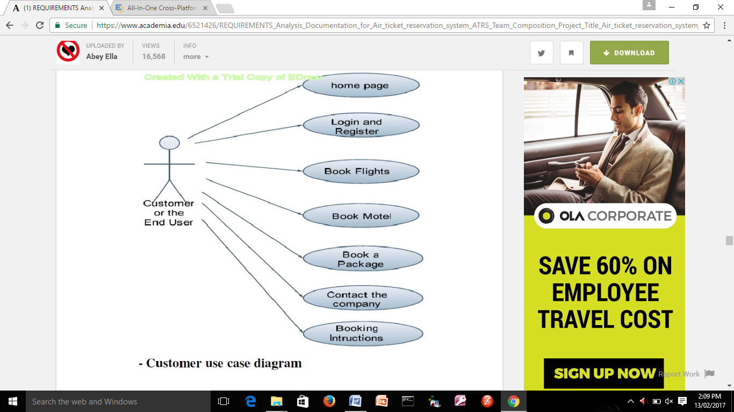Fig. 2

4.2 Use Case Description
To write the use-case specification consists of description about use-case flow of events such as basic flow, alternative flow, special requirement preconditions, and post conditions for the use-case “Reserve Tickets” of Airline Information System”.
BRIEF DESCRIPTION:
The reservation admin has to maintain flight status, flight details, reserve tickets and the particular use-case is used.
FLOW OF EVENTS
BASIC FLOW:
When the reservation admin has to maintain flight status means the system will show the reserved seats and the available seats in the flight status. The system which maintains the flight details which enter the flight ID, name, source, destination, arrival time, departure time. Reservation which is perform to reserve the tickets.
ALTERNATIVE FLOW
The reservation admin enters the wrong data means the system allows to reenter the reservation.
PRECONDITION
We have logged into enter the particular form.
POSTCONDITION
The system will add all the details, status of flight reservation form.
RESULT:
Thus the use-case specification was written successfully for Airline Information System.

4.3 Data Flow Diagram
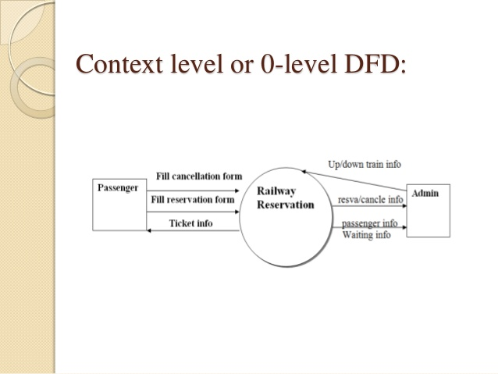
Fig.3
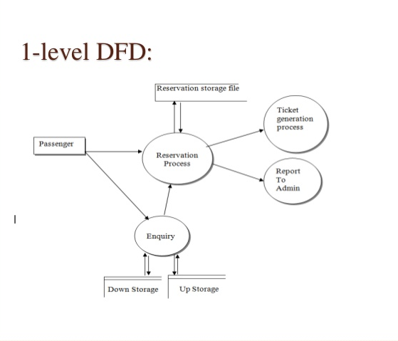

Fig. 4

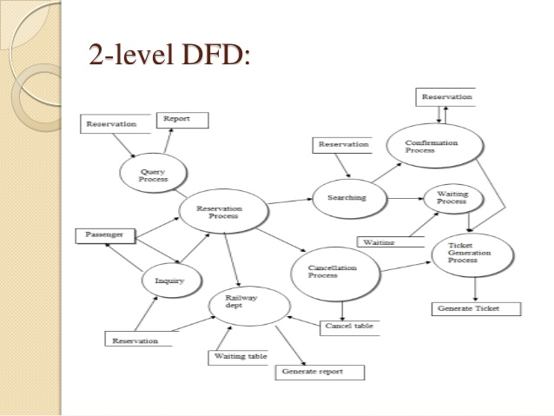

Fig. 5

4.4 Activity Diagram
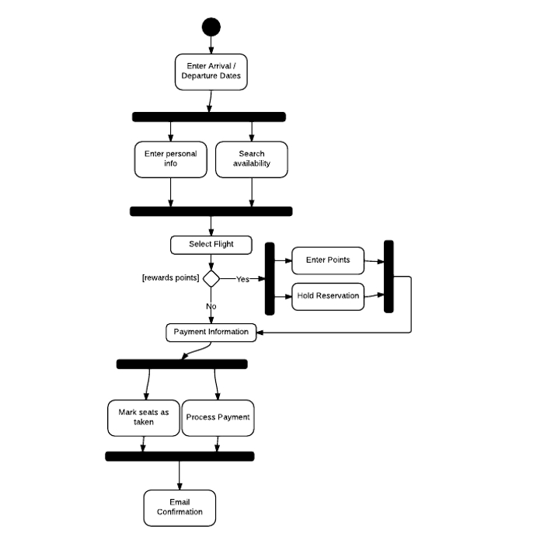

Fig. 6

4.5 Sequence Diagram
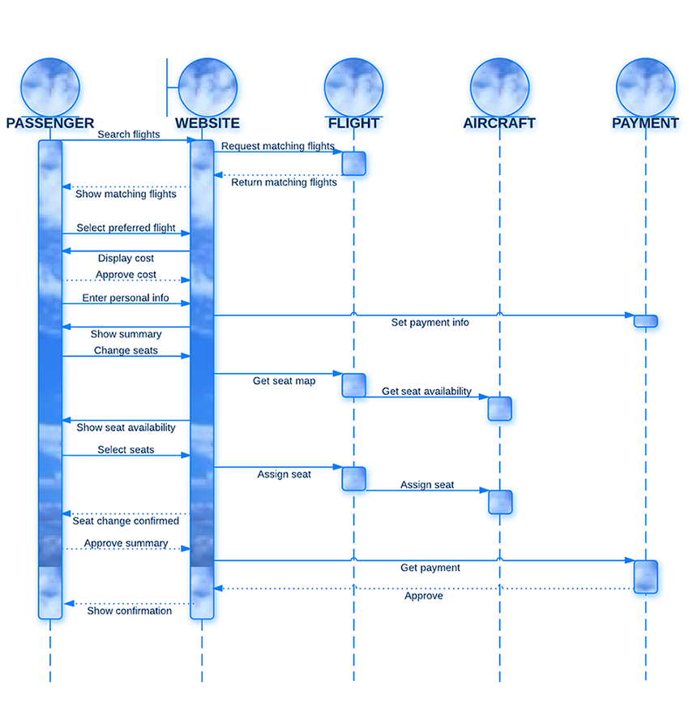
Fig. 7

Chapter 5
SYSTEM TESTING

The testing and implementation they are important and final phases. All the process that has been done is just a trail or by assumption. All the required hardware & software is prepared for the testing so that some errors or some modifications may be required for further proceeding.
5.1 Preparation of Test Data
The main objectives of the test plan are as follows:
- To identify the features of the system that will be tested.
- To identify and define all the activities necessary to prepare for and conduct the testing process on the Airline Reservation System
- To define the pass/fail criteria for each item that will be tested
- To identify the deliverables of the testing phase.
- To define any suspension criteria and resumption techniques
- To discuss the testing techniques being used to test the Airline Reservation System.

5.2 Black-Box Testing

- Black box testing is a process of checking the functionality of the application against specified requirements.
- It is used to find the following incorrect or missing
- Implementations of functions
- External database access
- Performance errors
- Initialization and termination errors
- It is also referred as Functional testing, Behavioural testing or Opaque testing
- This is done by the test engineers
- This Testing is done by the following testing methods
  - Functional Testing
  - Integration Testing

5.3 White- Box Testing
- White box testing is a process of testing every statement in the code and ensures that all statements and conditions have been executed at least once.
- It examines the program structure, hence it is called as structural testing.
- It is also referred as Glass box testing, Logic Driven testing, Path Oriented testing.
- This technique is typically applied at the Unit Test level, so it is performed by the Developers
- This Testing is done by the following testing methods:
- Statement coverage
- Path testing
- Condition testing
- Loop testing

5.4 Unit Testing
In this testing, the smaller part of the project is tested first that is modules and the sub functions present in the project. It seems to be working satisfactorily without the errors and that shows the unit testing is successful.
5.5 Integration Testing
The integration testing is an art that the software makes all functions behaviors and process required. The errors which are uncovered are integrated testing, are corrected during this phase. The collection of the functions are tested and found with errors are rectified .So that the result can be easily obtained in a successful manner.
  - System Testing
Testing is vital to the success of the system. System testing makes a logical assumption that if all parts of the system are correct. The goal will be successfully achieved. There are four steps as follows:
- Unit Testing
- Integration Testing
- Validation testing
- Output Testing

Chapter 6
CONCLUSION

6.1 Findings
There was a lot of fun in making this project. This project was very useful to us as it provided us the inside view of the planning and implementation of the database. In this project we had to think about the various options which we can provide to user. The implementation was not easy as we had to look into the minute details in order to achieve my goals. We have tried to make this project user friendly and also interactive by providing many features.
We are satisfied by achieving the goals for which we had planned. A lot of experimental work can be done with this project. Looking forward for any advice which can help us to improve the project.
6.2 Limitations
- Due to unavailability of templates it is impossible to generate different types of framework, here we need to develop them by our own.
- Since Microsoft and Java the testing becomes cumbersome.

6.3 Scope for Future Prospects
- For students desiring on-the-job experience prior to graduation, an internship course may be available.
- Graduates of the program will be prepared to assume positions as office managers, administrative services coordinators or assistants, office supervisors, records and information supervisors, personnel administrators, administrative assistants, or administrative support secretaries.
- Students may transfer to a four-year institution to pursue a bachelor’s degree in business administration, business education, human resources, advertising, or public relations
- Organization automation system is very helpful in collecting the record of an organization efficiently and in less time.
- It requires less man power to keep the record and to update it time to time quickly.
- Less skilled labor is needed to maintain the database in comparison to the traditional office management.
- Insertion and deletion of a particular field or any name in the any position except the last one is very typical in traditional office management but very easy in this case.
- Useful for collecting the record worldwide through the net and hence useful for multinational companies.

Chapter 7
BIBLIOGRAPHY & REFERENCES

7.1 Reference Books
Various books referred to for Java, HTML, CSS clarification and documentation are as follows:
- Advanced Java 2 Platform by Harvey. M. Dietal.
- Core Java 2, Volume II-Advanced Features by Cay Horetmann Gary Cornelll.
- Head First Servlets and Jsp by by Oreilly.
- Head First HTML with CSS by Chris Schalk(Author), Ed Burns (Author), James Holmes.
- Programming with Java by E. Balaguruswamy.

7.2 Other Documentation and Resources
Various sites referred to during making of the project are as follows:
- www.en.wikipedia.org
- www.google.com
- www.howstuffworks.com
- www.roseindia.net
- www.w3cschools.com

